Criminal charge pending - for now - against Hayner Hoyt whistleblower
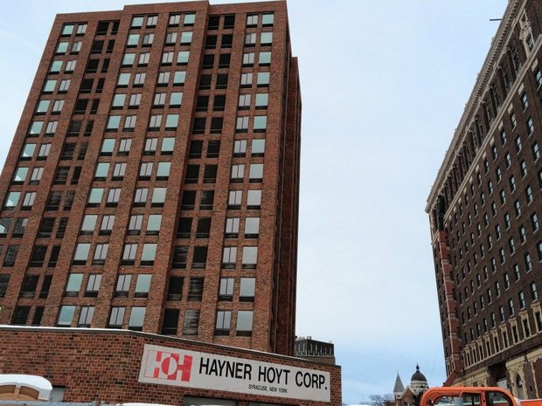
Hayner Hoyt Corp., the general contractor in charge of the $70 million renovation of the Hotel Syracuse, agreed to pay $5 million to settle a claim that a business it controlled improperly obtained $14 million in government contracts designed to go to small businesses owned by veterans with service-related disabilities, the Justice Department announced on March 14, 2016. (Rick Moriarty | rmoriarty@syracuse.com)
By Mike McAndrew | mmcandrew@syracuse.com
on March 14, 2016 at 4:02 PM, updated March 14, 2016 at 4:54 PM

Hayner Hoyt
- Criminal charge pending - for now - against Hayner Hoyt whistleblower
- Syracuse firm to pay $5M to settle claim it abused disabled vets program
- Former Hotel Syracuse tower to become extended-stay hotel
- Court ruling may speed up redevelopment of former Hotel Syracuse tower
- St. Patrick's School on Syracuse's Tipperary Hill reopening as loft apartments complete with blackboards (video)
All Stories

SYRACUSE, N.Y. -- The former Hayner Hoyt construction company vice president who was arrested shortly after blowing the whistle on the firm to federal authorities still has a grand larceny charge pending against him.
But that could change soon.
"We knew what was happening. We knew there was a whistleblower complaint. We have been talking to the feds since 2014," Chief Assistant District Attorney Rick Trunfio said of the charge against John Rubar.
Since Hayner Hoyt has agreed to pay $5 million in a settlement with the Justice Department over contract fraud allegations that Rubar raised, there will probably be a resolution soon in the criminal case against Rubar, Trunfio said.
He declined to say if the charge against Rubar will be dismissed.
Rubar's attorney, Michael Arcuri, said the DA's office has not promised to dismiss the charges, but he is hopeful.
"I don't know what they are going to do with it," Arcuri said of allegations that Rubar stole $266,000 worth of goods from Hayner Hoyt.
Rubar did not take anything owned by Hayner Hoyt when he was fired that he was not authorized to take, and he can prove that, Arcuri said.
"We feel it was retaliatory," he said of the criminal charge.
Rubar, a former Hayner Hoyt vice president, filed a whistleblower lawsuit against the company in July 2014, alleging that Hayner Hoyt's top executives, Gary Thurston and his son Jeremy Thurston, were involved in a scheme to improperly obtain government contracts in a program designed to help small businesses owned by veterans with service-related disabilities. He alleged in the lawsuit that Hayner Hoyt retaliated by firing him because he would not go along with the scheme.
Two months later, Syracuse police arrested Rubar, accusing him of stealing $266,000 over six years from Hayner Hoyt, according to archives of The Post-Standard. Hayner Hoyt President Jeremy Thurston had accused Rubar of taking hundreds of gallons of diesel fuel purchased by the company and using company credit cards to buy personal items, including home improvement materials and children's toys.
Rubar was briefly held in jail on a felony grand larceny charge, Arcuri said, but he did not have to spend the night there because prosecutors agreed to release him from custody.
The Justice Department intervened on Rubar's side in the civil lawsuit. Monday, it announced that Hayner Hoyt and the Thurstons had agreed to pay $5 million and had caused false documents to be filed with the government so that a company it controlled, 229 Constructors, could obtain $14 million in contracts that it was not entitled to receive.
But the company said in a public statement issued Monday that it never intended to violate federal law and settled the case to avoid a long investigation and legal expenses.
Hayner Hoyt issued this statement through its attorney, Michael Schaengold:
"The Hayner Hoyt Corporation never intended to violate the False Claims Act. When 229 Constructors was formed, a former official from the Small Business Administration, accountants, attorneys and a local VA contracting officer provided guidance to ensure that the business was not violating any rules," the statement said.
"The Hayner Hoyt Corporation decided to settle to avoid a prolonged investigation, business distractions and additional legal expenses. While the settlement is significant, it will not impact the company's ability to continue business operations. The Hayner Hoyt team celebrates 50 years in business in 2016. Hayner Hoyt was recently named a finalist for Community Involvement Business of the Year by CenterState CEO. The Hayner Hoyt team works hard and truly cares about the community where we live and work."
Despite Hayner Hoyt's claim of innocence, Rubar feels vindicated by the settlement, said Robert Sadowski, the lawyer who represented him in the whistleblower case.
"He's very happy. He does feel vindicated," Sadowski said.
Rubar suspected Hayner Hoyt of committing fraud to obtain government contracts because, among other things, he would see a disabled serviceman Ralph Bennett, who was supposed to be president of 229 Constructors, plowing snow on Hayner Hoyt property and working in Hayner Hoyt's warehouse.
He realized 229 Constructors was a "sham company," Sadowski said.
"It's reprehensible," he said of the Thurstons' conduct. "There was a $14 million contract that could have gone to give a head start to a business run by a service-disabled veteran. For their own greed, they deprived them of that. It's absolutely reprehensible."
Rubar's allegations that Hayner Hoyt retaliated against him by firing him and having him arrested were not resolved in the company's settlement with the Justice Department, Sadowski said.
"The lawsuit against Hayner Hoyt for bad behavior and retaliating against him will continue. We will continue that fight until he's fully vindicated," he said.
Rubar, who is now running his own construction company, could not be reached Monday for comment.

