Syracuse firm to pay $5M to settle claim it abused disabled vets program
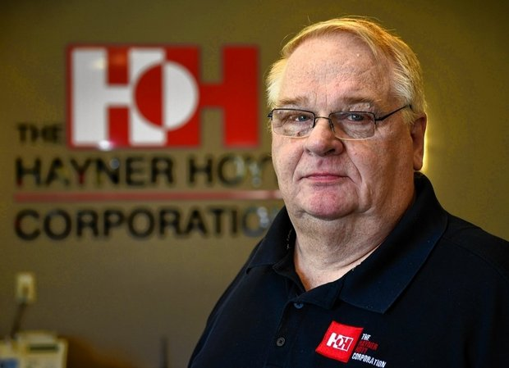
Gary Thurston, chairman and CEO of Hayner Hoyt Corp., was accused March 14, 2016 by federal prosecutors of scheming to abuse a government program that provides contracts to small businesses owned by disabled veterans. Haynor Hoyt, Thurston, and his son, Jeremy Thurston, the corporation's president, settled a civil suit by agreeing to pay $5 million to the government, according to the Justice Department. (Ellen Blalock | eblalock@syracuse.com)
By Mike McAndrew | mmcandrew@syracuse.com
on March 14, 2016 at 12:12 PM, updated March 14, 2016 at 4:14 PM

SYRACUSE, N.Y. -- Syracuse construction company Hayner Hoyt Corp. has agreed to pay $5 million, plus interest, to settle government claims that it abused a program designed to provide contracting opportunities to small businesses owned by disabled veterans.
Hayner Hoyt Corporation Chairman and Chief Executive Officer Gary Thurston, his son, Hayner Hoyt President Jeremy Thurston, employees Ralph Bennett and Steve Benedict, and Hayner Hoyt affiliates LeMoyne Interiors and Doyner Inc., engaged in conduct designed to exploit the program, the Department of Justice alleged.
The settlement ends a civil case that alleged the defendants took advantage of the service-disabled, veteran-owned small business program and secured $14.4 million in government contracts for a now-defunct company, 229 Constructors LLC, that Gary and Jeremy Thurston created and controlled.
To be eligible for the Department of Veterans Affairs contracts, a service-disabled veteran must own and control a small business and handle its strategic decisions and day-to-day management.
But a Justice Department investigation showed that Bennett – a service-disabled veteran who was 229 Constructors' president – was not involved in making important business decisions for the company. He was instead responsible for overseeing Hayner Hoyt's tool inventory and plowing snow from Hayner Hoyt's property, according to U.S. Attorney Richard Hartunian.
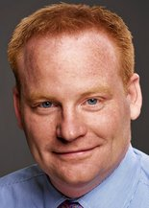Jeremy ThurstonProvided photo
The Thurstons – neither of whom is a veteran – exerted significant influence over 229 Constructors' decision-making during the bid, award and performance of these contracts in various ways, including by staffing the company entirely with then-current and former Hayner Hoyt employees and their spouses, the U.S. Attorney's Office alleged.
The Thurstons also provided 229 Constructors with considerable resources, which provided it with a competitive advantage over legitimate service-disabled veteran-owned small businesses that weren't controlled by a larger, non-veteran owned corporation, prosecutors alleged.
Hayner Hoyt officials caused false certifications and statements to be filed with the government representing that 229 Constructors met all requirements to be a service-disabled veteran-owned small business when they knew, or should have known, that 229 Constructors did not meet such requirements, according to prosecutors.
Hayner Hoyt is one of the best-known construction companies in Central New York. It's recent projects have included renovating the Hotel Syracuse and construction of the $19 million Carmelo Anthony Basketball Center at Syracuse University. It has also built high-tech facilities for Inficon, Lockheed Martin, Advion Biosciences, Anaren, Bristol-Meyers Squibb, and SRC, as well as a yogurt manufacturing plant owned by Byrne Dairy, according to the Haynor Hoyt website.
"We hope that today's settlement sends a message that conduct of this nature is unacceptable," said Assistant U.S. Attorney Adam Katz. "It's a very good question why they (Hayner Hoyt) needed to do this. In factoring an appropriate settlement, we certainly considered that Congress wanted to create opportunities for those who have served our nation. The Thurstons' conduct undercut that goal."
The government's investigation was triggered by a whistleblower lawsuit filed under the qui tam provisions of the False Claims Act, which allows private persons to file lawsuits on behalf of the United States and share in any recovery.
The whistleblower, identified in court papers as John Rubar, will receive $875,000 of the settlement proceeds.
Rubar's suit, filed in July 2014, said that he was retaliated against and fired as vice president of the Hayner Hoyt subsidiary Doyner Inc. when he refused to go along with the scheme.
About two months after Rubar's lawsuit was filed, Syracuse police arrested Rubar, of Constantia, and accused him of stealing $266,000 over six years from Hayner Hoyt, according to archives of The Post-Standard. He was charged with a felony count of grand larceny, police said at the time. The story said that Rubar had been hired by Hayner Hoyt in 1991 and worked his way up to vice president. Jeremy Thurston told police he found that Rubar made several 200-gallon purchases of diesel fuel that were delivered to Rubar's home and used company credit cards to buy personal items, including home improvement materials and children's toys.

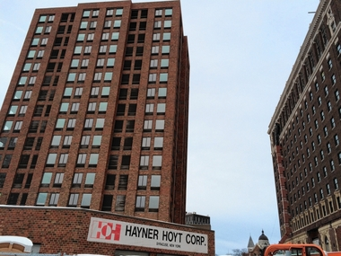
Criminal charge pending - for now - against Hayner Hoyt whistleblower
Hayner Hoyt agreed to pay $5 million to the U.S. government to settle the whistleblower lawsuit, but says it never intended to violate federal law.
Rubar's allegations that Hayner Hoyt retaliated against him were not resolved in the settlement with the Justice Department, Katz said.
Katz alleged:
Jeremy Thurston set up an email account in Bennett's name in such a way that all emails received by the veteran were automatically forwarded to him. After the government began to question 229 Constructors' affiliation with Hayner Hoyt, Gary Thurston wrote others that he and Jeremy Thurston would likely terminate operations of 229 Constructors.
A few months later, service-disabled veteran Bennett and Benedict, who was simultaneously the "co-owner" of 229 Constructors and listed on Hayner Hoyt's website as one of its five "key" officials, transferred a total of $52,000 to Gary Thurston's personal bank account allegedly to show their appreciation for the assistance he had provided.
As part of the settlement, the Hayner Hoyt defendants admitted that their conduct violated federal regulations designed to encourage contract awards to legitimate service-disabled veteran-owned small businesses, prosecutors said.
They also admitted that 229 Constructors provided more than $1.3 million in service-disabled veteran-owned small business subcontracts to Hayner Hoyt, LeMoyne Interiors and Doyner and that those companies generated $296,819 in gross profits as a result.
"Those who do business with the federal government must do so honestly," said Hartunian. "As today's settlement demonstrates, this office will vigorously pursue those individuals and entities who game programs designed to help our nation's veterans succeed in starting small businesses."
Hayner Hoyt could potentially face other consequences. In settlements involving contract fraud or misrepresentations, government agencies sometimes opt to bar companies from obtaining future government contracts. That has not happened yet with Hayner Hoyt.
The investigation and settlement were the result of a coordinated effort among the U.S. Attorney's Office for the Northern District of New York, the Small Business Administration's Office of Inspector General, the Veterans Administration's Office of Inspector General, and the Defense Criminal Investigative Service.

